Knowledge Extraction Expert -- Jiangsu Yun Academy Network Technology Co., Ltd. Internship Report
Jiayi Wu

1. Background
1.1 Internship Company
I interned at Jiangsu Yun Academy Network Technology Co., Ltd. during the summer of 2024. This company provides enterprise learning and training platform systems for other medium and large enterprises (averaging over 2,000 employees). Yun Academy serves over 2,500 industry clients across more than 20 industries, with many top-tier customers in various fields; they are industry leaders in AI education.

1.2 Internship Department
I interned in the AI Platform Department, where I learned how to interface with large model APIs and use Prompt engineering and techniques to enhance AI capabilities. I also learned to use AI application and engineering development frameworks such as Langchain and Llamaindex, and was responsible for developing AI Agents based on these frameworks (AI systems with strong capabilities in specific domains that can utilize tools to understand external information and efficiently complete tasks).

1.3 Enterprise Problem Solving and Value
Through communication with senior employees and personal reflection and practice, I identified the following problems existing in enterprises and the value that AI Agents can bring to solve them:
In today's rapidly developing business environment, enterprise success often depends on the professional capabilities of internal experts and the depth and breadth of their knowledge. However, as enterprise scale expands and business complexity increases, an undeniable problem gradually emerges: there is an imbalance in expert capabilities within enterprises, and their knowledge is often limited to individuals, making it difficult to achieve efficient sharing and transfer throughout the organization. This phenomenon not only limits the full utilization of internal knowledge resources but also affects the organization's overall learning and innovation capabilities. To break through this bottleneck and improve organizational learning efficiency and innovation capability, we propose an innovative solution: developing an AI Agent that can extract, organize, and share expert knowledge.

2. Problems and Challenges
2.1 Knowledge Dispersion and Isolation
Expert knowledge within enterprises is often scattered among individuals, lacking unified management and integration. For enterprises to utilize their resources most efficiently for development, they need a real-time updated knowledge base that captures knowledge points from experts in various fields and provides constant awareness of the enterprise's capability scope—making goal and strategy planning and implementation clearer and more defined. The current state of knowledge dispersion leads to waste of internal knowledge resources and inability to form effective knowledge sharing and transfer mechanisms. Knowledge isolation also makes it difficult for team members to collaborate efficiently, as each person only masters knowledge in their own field and lacks understanding of other domains.

2.2 Low Knowledge Transfer Efficiency
Traditional knowledge transfer methods, such as training and meetings, are not only inefficient but also difficult to guarantee knowledge accuracy and completeness. This inefficient knowledge transfer method limits organizational learning and innovation capabilities.

2.3 Difficulty in Knowledge Updates
As enterprise business continues to develop and markets change rapidly, knowledge also needs continuous updating and supplementation. However, traditional knowledge management methods often struggle to update timely, leading to outdated and obsolete content in enterprise knowledge bases.

3. Solution Value
3.1 Improve Knowledge Sharing Efficiency
Through AI Agents, enterprises can achieve rapid extraction and efficient sharing of expert knowledge, enabling full utilization of internal knowledge resources. This not only improves collaboration efficiency among team members but also promotes knowledge exchange and integration between different departments.

3.2 Enhance Organizational Learning Capability
Using AI Agents can establish a comprehensive knowledge base, providing a convenient learning platform for organizational members. Through professional knowledge extracted from multiple experts by AI Agents, employees can learn required knowledge more efficiently, improving individual and organizational learning efficiency. Meanwhile, since AI has no feelings of boredom, difficult-to-understand questions can be asked repeatedly, ensuring deep understanding and mastery of knowledge.

3.3 Support Decision Making
AI Agents can help enterprise leadership quickly understand the distribution of capabilities and resources within the organization, providing strong support for decision-making. Through data analysis and mining of the knowledge base, enterprises can more accurately grasp their own capabilities and formulate strategic plans that better align with market development trends.

3.4 Promote Innovation
AI Agents can integrate and collide extracted knowledge, sparking new innovative ideas. With the help of AI Agents, enterprises can more easily discover new business opportunities and potential innovation points, injecting new vitality into enterprise development.

3.5 Real-time Updates and Dynamic Management
AI Agents possess real-time updating and dynamic management capabilities, able to timely supplement and update knowledge base content according to personnel changes and technological developments. This ensures the timeliness and accuracy of enterprise knowledge bases, providing more reliable knowledge support for enterprises.

4. Project Concept Design
4.1 Project Overview
The Knowledge Extraction Expert is an AI Agent group with simple and efficient interaction, self-supervised goal completion, and capabilities for knowledge analysis, evaluation, and summarization. By setting extraction goals, Agents can extract and organize knowledge points during conversations with real human experts, thereby achieving sharing and inheritance of internal enterprise knowledge and creating an environment where knowledge can flow efficiently. Essentially, this is a process of interviewing human experts and obtaining information from conversations.

4.2 Knowledge Flow Vision
The purpose of this project is to enable efficient circulation of knowledge within enterprises or organizations, while allowing enterprise decision-makers and personnel to understand the scope of fields the enterprise touches at any time. By constructing knowledge trees to centralize knowledge, forming a closed loop of expert → knowledge tree, knowledge tree → expert, allowing knowledge to take root and exist in the enterprise's work and development atmosphere. Experts can easily interact with knowledge, timely updating and obtaining knowledge; when experts communicate with each other, they can understand each other's domain expertise through knowledge trees, facilitating communication; when beginners want knowledge in a certain field, they can find the most capable person and seek more guidance...

4.3 Core Implementation Goals
- Design AI Agent groups capable of automatically interacting with experts, ensuring completion of set extraction goals through efficient dialogue and extracting core knowledge points from experts.
- Ensure extracted knowledge content has high professionalism, accurately reflecting experts' professional level and domain knowledge, while prioritizing knowledge relevance and avoiding misunderstandings or off-topic situations.
- Agents can efficiently interact with real human experts while respecting interviewees' feelings. Gain expert trust through real-time summarization and evaluation, displaying extracted knowledge trees, etc.
- The Knowledge Extraction Expert is an AI Agent group prioritizing goal completion, maximizing efficiency in understanding information during conversations, with certain adaptive capabilities. Essentially, this is a process of generating questions based on goals - obtaining knowledge through dialogue - evaluating knowledge.

5. Concept Definitions and Terminology Clarification
5.1 Agent
- Agents have the ability to interact with Large Language Models (LLMs) and can store information and use tools to access databases and external information.
- Agents can communicate and interact with each other, while each Agent has internal workflows that can operate in parallel/serial/loop modes.

5.2 Knowledge Tree Definition
- A knowledge tree is a database containing all extracted knowledge.
- Before starting conversations with experts, construct a basic knowledge tree using existing enterprise knowledge (related to theme goals) and externally obtained core knowledge. This forms basic consensus with experts while saving time from discussing shallow content.
- When expert knowledge passes evaluation standards, it needs to be updated to the knowledge tree according to associations and classifications with existing knowledge in the tree.

5.3 Theme Definition
- Themes inform human experts and AI Agents about the background information and core content of this interview. Having themes aims to define conversation scope and prevent knowledge from spreading too broadly.

5.4 Goal Definition
- Goals are tasks that AI needs to complete during interaction with human experts. These goals are often broad, and through AI analysis of all tasks, efficient questions are organized to complete goals. Through expert answers and evaluation of answers (defining standards for goal completion), determine whether goals are completed.
- When human experts' answers are interesting and cover content beyond goals, if relevant, they can be synchronously updated to the knowledge tree, or new questions can be generated for that angle for in-depth discussion.
- Perfect compliance with goal standards is not required. Meeting core goal standards ensures goal completion efficiency.

5.5 Knowledge Definition
- Knowledge points exist in many forms and have many classifications; in the context of Knowledge Extraction Expert, knowledge is explanation of target questions.
- Knowledge is multi-dimensional, and all these knowledge should exist structurally in the knowledge tree according to relationships between them.
- Knowledge mainly includes four aspects: basic knowledge concepts/terminology, why knowledge is important, core knowledge content structure, and illustrative examples.

5.6 Question Definition
- Questions are inquiries made to human experts when obtaining information, generated by generation Agents with goal completion orientation.
- When generating questions, the most appropriate questions need to be generated with the purpose of maximizing efficiency in completing goals, preventing repetitive inquiry of existing knowledge, and reaching consensus with human experts.

5.7 Process Definition
- Each Agent can have multiple Prompt cards and data cards. Prompt cards record the Prompts used when Agents interface with LLMs, while data cards are attribute variables that Agents possess.
- Each card can be pre-modified, and human experts also have partial modification permissions, depending on conversation themes and methods. Cards will be modified by Agents themselves during conversations, and Agent status can be understood by viewing cards; the entire Agent group also has certain adaptive capabilities. More card-related information can be referenced in section 6.10.

6. Core Questions
6.1 What exactly is the Knowledge Extraction Expert extracting?
- The core driving force of the Knowledge Extraction Expert is to complete goals provided by interview initiators. According to our definition of knowledge, the Knowledge Extraction Expert will organize questions according to goal standards, attempting to collect relevant multi-dimensional information, including but not limited to: knowledge concepts or definitions, knowledge value, application scenarios, relevant data, connections with other knowledge (if existing), provided cases and theoretical support, etc.
- Before formally starting interviews, provide interview initiators with an Interview Outline—a form about extraction goals, scope, and time planning for this interview, letting interview initiators understand whether this goal meets their expectations.

6.2 How to solve human expert trust issues? Why can my Knowledge Extraction Expert be trusted?
- Expert trust can be improved from information transparency perspective. Display goal completion progress, provide real-time evaluation feedback, show constructed knowledge trees in real-time, letting experts understand AI work efficiency and capabilities.
- Experts can change Agent working methods by adjusting Prompt cards and data cards, making Agent working modes meet expert expectations.
- Provide experts with Interview Outlines to achieve consensus between experts and interview initiators. If outlines have problems, they can be corrected before conversations begin.
- If experts are unwilling to discuss certain questions in depth, indirect methods can be used to repeatedly attempt through roundabout approaches.
6.3 How to evaluate knowledge depth and breadth? What are the measurement standards?
- Depth refers to the thoroughness of knowledge research. High-professional knowledge should have basic concepts and principles and be able to apply them to deeply explore and explain various complex problems. Judging whether answer depth is sufficient needs to focus on: whether facts are correct, whether logic is clear and rigorous, feasibility, whether there are appropriate supporting examples, whether there are relevant theories or other industry viewpoints for support, etc. A highly professional answer will have multiple dimensions, and we can judge professionalism by seeing how many aspects expert answers contain. Analysis and evaluation Prompt cards will provide analysis and evaluation Agents with professionalism gradients for reference.
- Breadth refers to knowledge completeness and applicability. An answer with breadth should be applicable to various different complex situations and analyze problems from multiple angles. Answer breadth depends on: whether problems are analyzed from multiple aspects, whether different situations are established with professional analysis provided separately, whether other related problems are mentioned, etc. We can start evaluating from how many angles experts analyze—the more angles the better, but we must also ensure each angle doesn't go off-topic and has direct/indirect relationships with target questions.
- Before knowledge has depth and breadth, relevance to target tasks must first be verified. Whether relevance, depth, or breadth fail to meet standards, analysis and evaluation Agents will provide timely feedback, and generation Agents will generate new tasks to feedback to experts, requesting new answers. (See Agent in section 6.6)

6.4 How to manage knowledge, what structure to use for storage, how to update and iterate in real-time?
- Knowledge exists in a relationship graph format. Each extraction has a separate theme, and themes contain multiple goals. Goals branch out different knowledge points, and each knowledge point has concepts or definitions. Knowledge points can continue expanding their value, applications, cases, relevant data, and possible connections with other knowledge. Values can have multiple additional branches, applications can have multiple branches adapting to different situations, and of course, multiple cases can exist. See figure 6.3.
- Knowledge stored in databases is structured with clear relationships. Visualized knowledge trees can be directly constructed and displayed to experts.

6.5 What is the interactive interface design like? What information should I provide to human experts?
- Knowledge tree display showing extracted and constructed knowledge base
- Professionalism and relevance scores for knowledge points (changing in real-time)
- Professionalism and relevance evaluation standards for knowledge points (experts can modify according to their ideas)
- Goal completion progress and conversation time
- Expert-modifiable Prompt card and data card interfaces
- Interactive buttons, dialogue boxes, and other common essential UI elements
6.6 What is the interaction process like? How many sub-modules are involved in each conversation round, and how do they work and interact?
- Theme Module: Preset themes, providing background information to conversation modules.
- Conversation Module: Supports natural, fluent conversations with real human experts. Responsible for obtaining questions most relevant to current conversation rounds and organizing language to inquire experts. Provides current goals, questions, and expert replies to analysis and evaluation modules.
- Analysis and Evaluation Module: Scores relevance and professionalism according to evaluation standards (such as evaluation gradients, existing database information). Expert answers meeting conditions can be given to storage modules; insufficient parts need evaluation comments given to generation Agents for priority consideration in follow-up questions when generating questions. Experts can view analyzed knowledge from analysis and evaluation modules and their scores and evaluations anytime.
- Generation Module: Based on remaining goals, conversation information, analysis and evaluation module results, collected knowledge, external tools, and supervision module guidance. If goal knowledge points need correction and supplementation, prioritize questions about these aspects and place them at the front of question libraries; when expert-mentioned knowledge has value, continue following up. Generation modules should maintain high emotional intelligence when generating, embedding questions in appropriate and fluent conversations.
- Supervision Module: Real-time monitoring of various possible situations; ensuring smooth conversation progress and task completion. Modify other modules' Prompts when necessary to change behavior.
a. Monitor goal completion: When expert-provided knowledge meets goal completion standards, confirm with experts and mark goals as completed
b. Monitor completion efficiency: Record conversation time and number of completed goals, evaluate efficiency. Assess whether to accelerate if progress is too slow, such as first understanding core content like concepts for each goal
c. Monitor question situations: If after generating a question, expert's previous explanations already contain its content, delete this question and regenerate
- Summary Module: After goals are achieved, combine with other experts' results to summarize and update summary knowledge base. Summary process is similar to storage module, obtaining current expert knowledge tree and updating unique and superior knowledge to summary knowledge tree. Note that important information cannot be lost during summary and merging processes, but redundant information should not appear.

6.7 What are task completion standards? When do generation Agents advance?
- We can roughly plan task progress through preset knowledge dimensions, for example, if 5 knowledge points have been extracted for a goal, including scenario applications, cases, and analysis, it's considered complete, allowing estimation of approximate progress.
- Follow-up mode doesn't easily determine absolute completion of knowledge point extraction, but we can set extraction conversation rounds and combine with above task progress estimation, for example, assuming completion after 20 conversation rounds with multiple knowledge points. When completing, let experts judge whether goals are truly achieved and whether to continue discussion.
- Experts can make completion judgments by viewing real-time updated knowledge trees. If knowledge for a certain goal has been collected comprehensively and deeply, experts can proactively mark goals as completed.

6.8 How to summarize knowledge from different experts? When consolidating multiple experts' knowledge, how to avoid unnecessary information loss and synonymous repetition?
- Compare current expert knowledge base with enterprise summary knowledge base, see if application scenarios, values, cases, etc. provided by both sides are different, and add new parts as supplements.
- If contradictory viewpoints appear between knowledge trees, preserve both as adjacent nodes for customers to distinguish themselves.
- If there are similar knowledge points but professionalism gaps (e.g., total score 100, difference of 30 points), then choose the better one, and highly-scored parts of weaker knowledge points can be added as supplements.
- All knowledge points and branches must be labeled with expert names for easy identification.

6.9 Besides knowledge extraction, what else can these AI Agents do?
- Although this project is a Knowledge Extraction Expert, the core framework can be generalized. Essentially, this is a multi-AI Agent framework of conversation-evaluation-feedback; changing interaction content and theme goals can achieve other functions.
- Customizable cards actually facilitate subsequent modifications and supplements. Each Agent's core is conversing with LLMs based on information. We can adjust their functions by modifying Prompt cards and data cards.

6.10 What are Prompt cards and data cards? What can they do?
- Each Agent has Prompt cards and data cards, showing information they use when accessing LLMs and working. Each card records this information in detail, allowing experts to intuitively see what each Agent is doing and make adjustments when appropriate.
- Prompt cards are Prompts each Agent uses when interacting with LLMs. Each Prompt card separately shows a certain function of this Agent. These Prompts can access LLMs in parallel, serially in sequence, or combine Prompt information before accessing. Experts can modify Prompts anytime to make LLMs return more appropriate information.
- Data cards are attribute parameters each Agent uses when interacting with LLMs and partial results output by LLMs. Conceptually, data cards show certain Agent attributes and settings. When these attributes and settings aren't suitable for current tasks, experts can modify them anytime.

7. Concept Diagrams
7.1 Interactive UI Interface
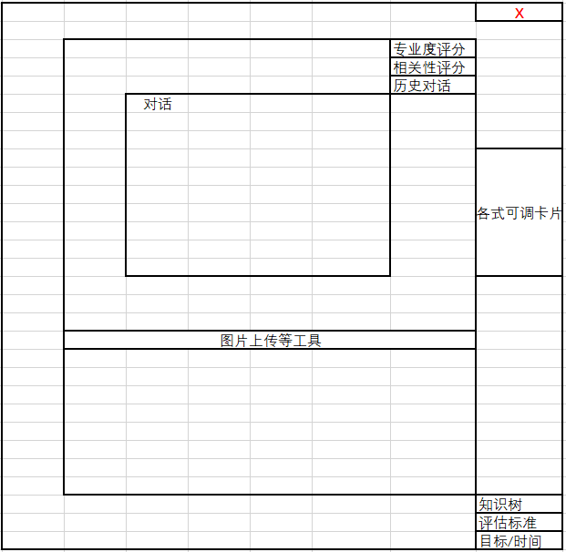
[Diagram showing interface layout with knowledge tree display, progress tracking, and conversation interface]

7.2 Question Generation Concept Diagram (Example)
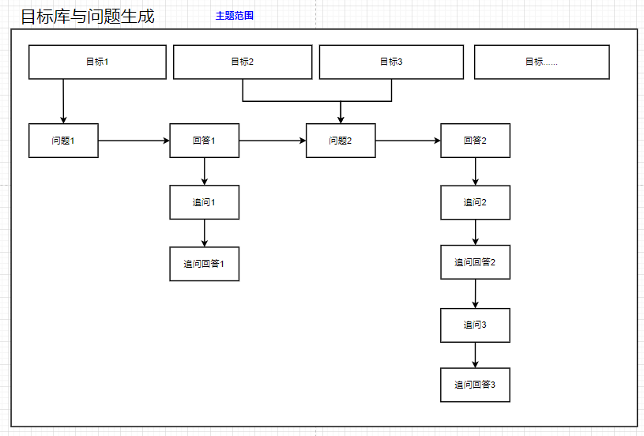
[Flowchart showing the process of question generation from goals to specific questions]

7.3 Simplified Workflow Diagram
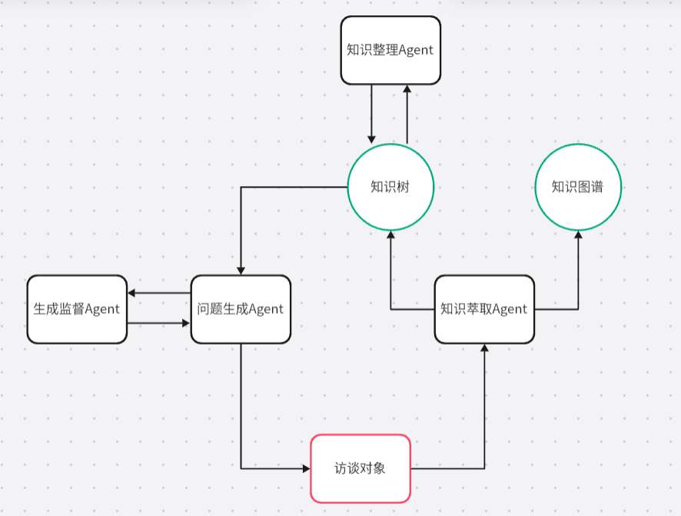
[Process flow showing the interaction between different agents and modules]

7.4 Knowledge Graph
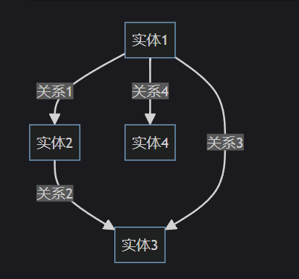
[Network diagram showing relationships between knowledge concepts]

7.5 Knowledge Tree
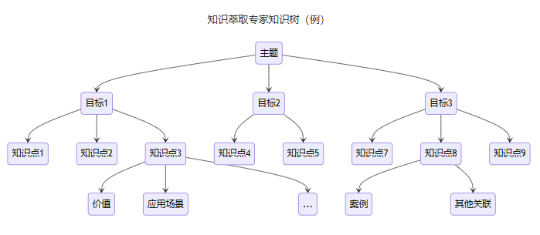
[Hierarchical tree structure showing knowledge organization]

8. Agent Design and Implementation
8.1 Generation Agent
This Agent is responsible for conversing with human experts and generating new questions. Through themes and goals, generation Agents will ask human experts in appropriate order. It can also select the best questioning methods based on conversation history and extracted knowledge trees; it will have high emotional intelligence, embedding questions in fluent conversations and being able to deepen questions or change topics at appropriate times.
Generation Module: The focus of generation Agents is designing good Prompts to make them understand their responsibilities and boundaries. I will use methods like Roleplay (playing experienced reporters), Few-Shot, and CoT to strengthen their capabilities. Use high-quality Prompts to make them reasonably and emotionally intelligently respond to human experts and raise appropriate questions.

8.2 Extraction Agent
This Agent is responsible for extracting knowledge points from human expert replies and placing them on knowledge trees when received. It will first evaluate knowledge relevance and professionalism, then place knowledge points in corresponding locations, ensuring extracted knowledge is professional and accurate, and storage locations have correct relationships with other knowledge points. When knowledge trees are found to have defects, it's also responsible for reconstructing knowledge trees to make content structure more accurate.
Theme Module: This module can be directly embedded in conversation extraction Agent Prompts. Most LLMs have extensive knowledge; as long as corresponding theme Roleplay is provided in Prompts, their performance will appear professional (e.g., telling AI it's an expert in a certain field).
Extraction Module: By inputting extracted knowledge trees, conversation history, and current human expert replies, extraction Agents can extract knowledge from replies and update knowledge trees. Extraction Agent Prompts use methods like Prompt-Based Tool Call, Roleplay (playing data extraction analysts), Few-Shot, and CoT. Use high-quality Prompts to precisely manipulate output, informing us of operations needed on knowledge trees.

8.3 Evaluation Agent
Since human experts often master deeper knowledge, AI Agents cannot make very precise analysis and evaluation. Use Prompts to create relevance/professionalism evaluation forms, providing feedback to human experts for final knowledge content determination. Ensure knowledge conforms to common sense and has no logical errors. Additionally, this module has knowledge tree reconstruction capabilities, allowing experts to easily adjust incorrect knowledge structures through multiple calls to this function.

8.4 Feedback Agent
The feedback module focuses on improving generation Agent reply quality and perspectives. Since generation Agents obtain massive data and must consider multiple factors to output replies, they struggle to balance all variables, creating priority problems. Feedback modules will have priority rankings for generation question considerations and audit generation Agent questions accordingly. For example, when time is insufficient, feedback modules will make generation Agents focus on important questions and skip current conversation details.

9. Results Demonstration
9.1 Process Demonstration
- Pre-load topics and tasks for this extraction interview, plus human expert information
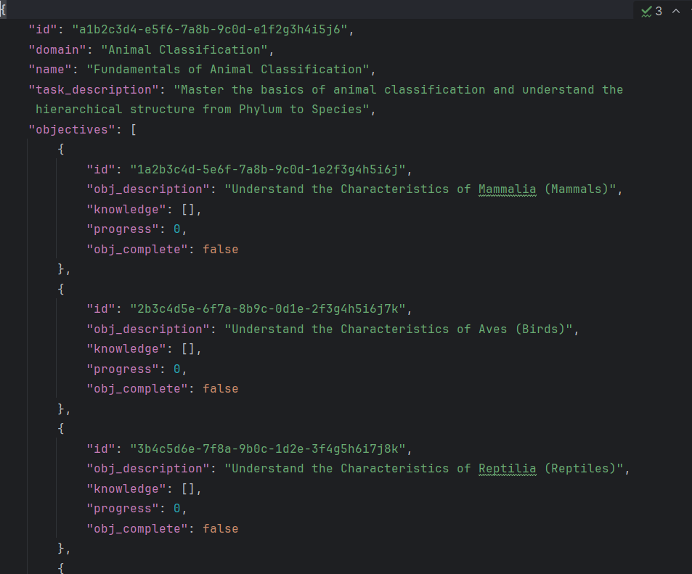
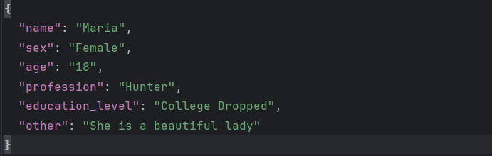

- Start extraction: Choose extraction expert's tone and style

- Generation question Agent generates responses, through discussion with feedback Agent, finalizes ultimate replies and questions
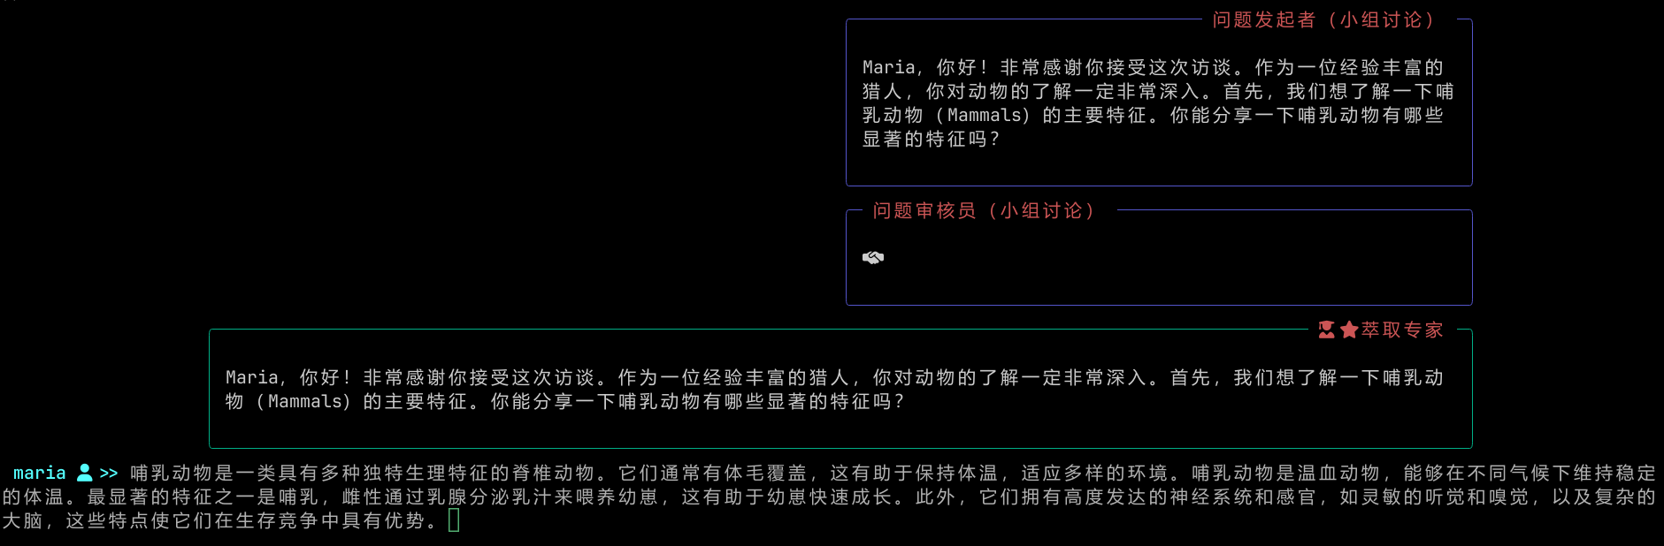
- Human experts see questions and reply, can also use various customization functions during this time
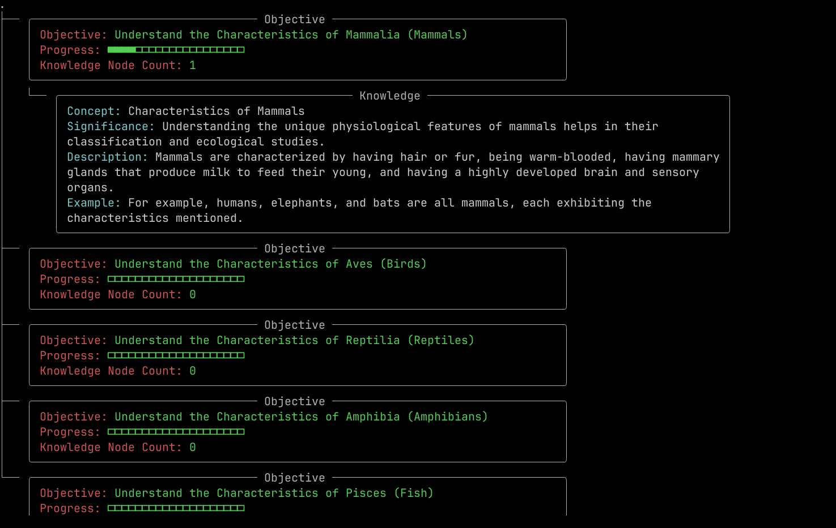
- Expert replies are received by extraction Agents, after evaluation and splitting, knowledge points are added to knowledge trees and knowledge graphs
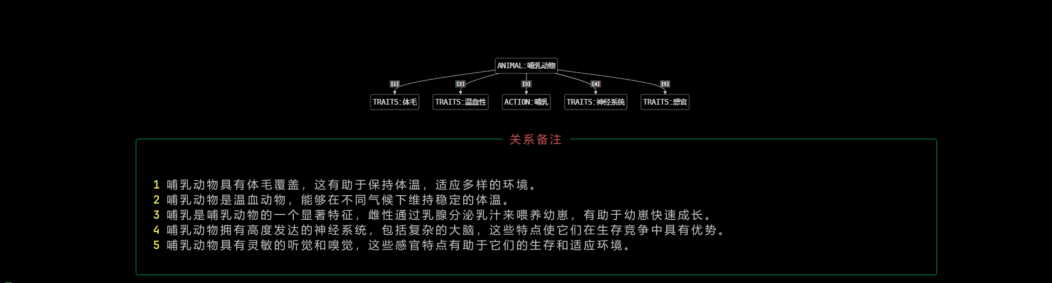
- Continue generating new questions when time hasn't ended/goals aren't all completed, otherwise end this extraction interview
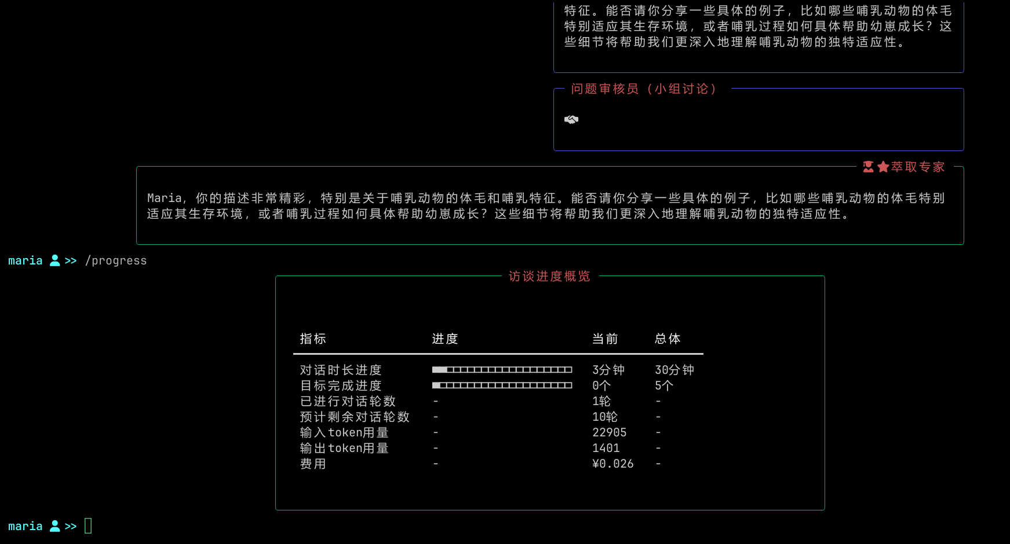
9.2 Function Demonstration
- Generation Agents can change conversation direction at appropriate times through group discussions to care for human expert feelings or improve time efficiency
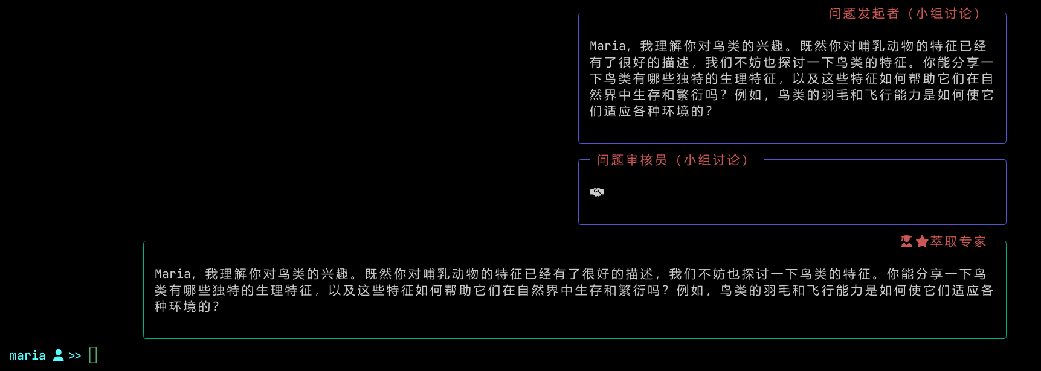
- Generation Agents provide timely feedback and opinions to human experts based on extracted knowledge, ensuring professional and fluent conversations
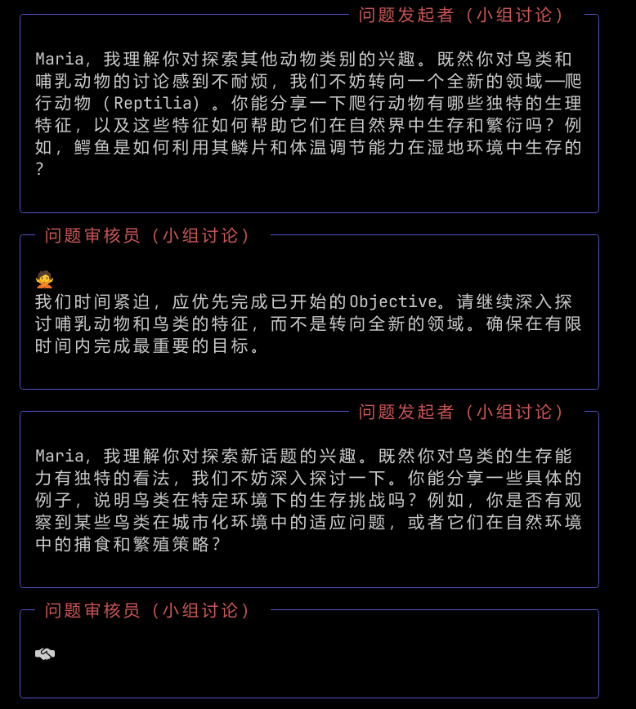
- Extraction Agents can capture most key knowledge from human expert replies and store them appropriately
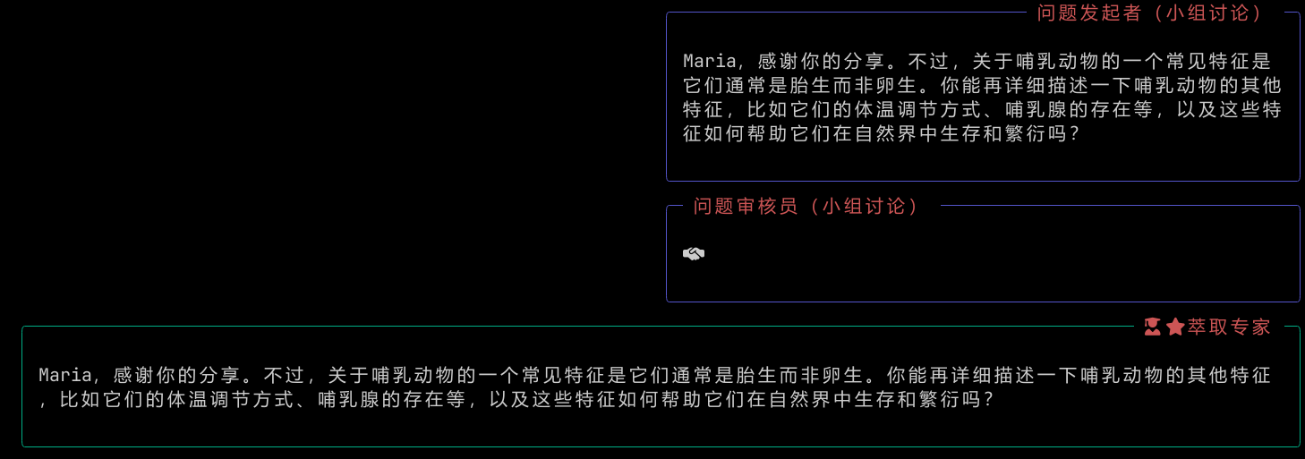
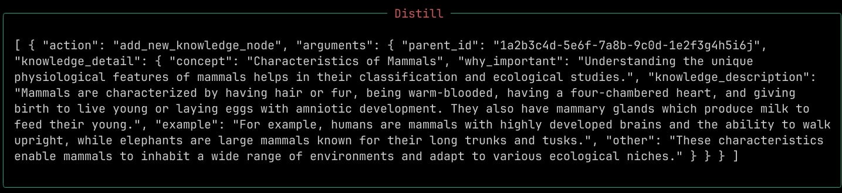
- Extraction Agents can evaluate relevance and professionalism of human expert replies. Content that isn't relevant or professional enough won't be recorded, and generation Agents will ask experts for confirmation
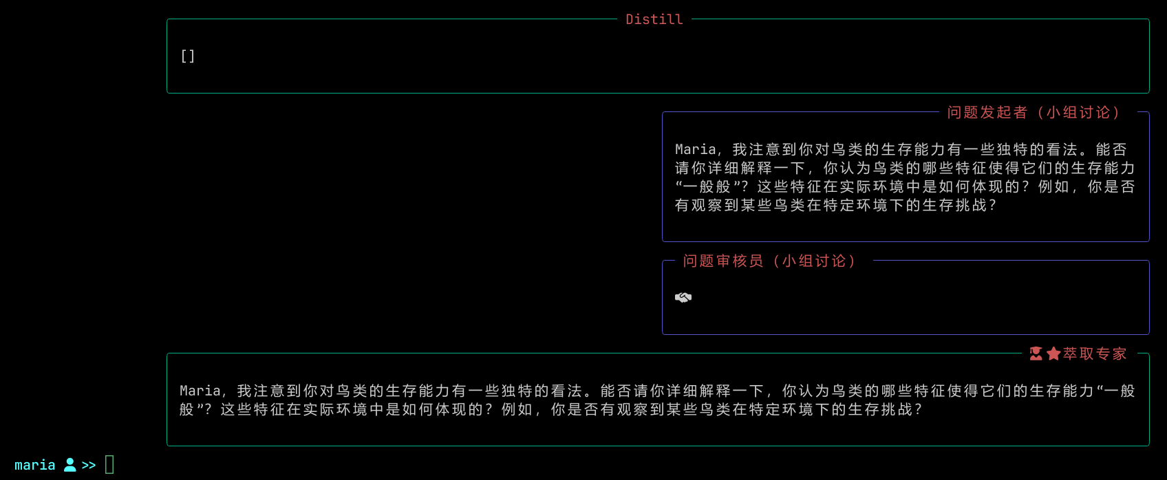
9.3 Customization Functions
- Voice input/output (ASR/TTS) - Command: /asr
- Simulate expert Agent - Let AI pretend to be human expert for supplements - Command: /auto
- Snapshot function - Save/Load interview progress anytime - Command: /dump
- View extracted knowledge anytime (knowledge tree/knowledge graph) - Commands: /tree & /graph
- View Prompts used by each Agent anytime - Commands: /generation-prompt & /summary-prompt & /distill-prompt
- Evaluation Agent refine knowledge tree anytime, Redo/Undo anytime - Commands: /refine & /undo & /redo
- View interview progress anytime (time, goal completion, etc.) - Command: /progress
- Generation Agent and feedback Agent internal group discussions to optimize questions

9.4 Prompt Engineering
- Multi-level nested Examples design, Few-Shot
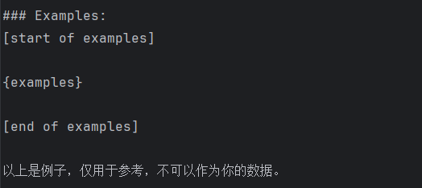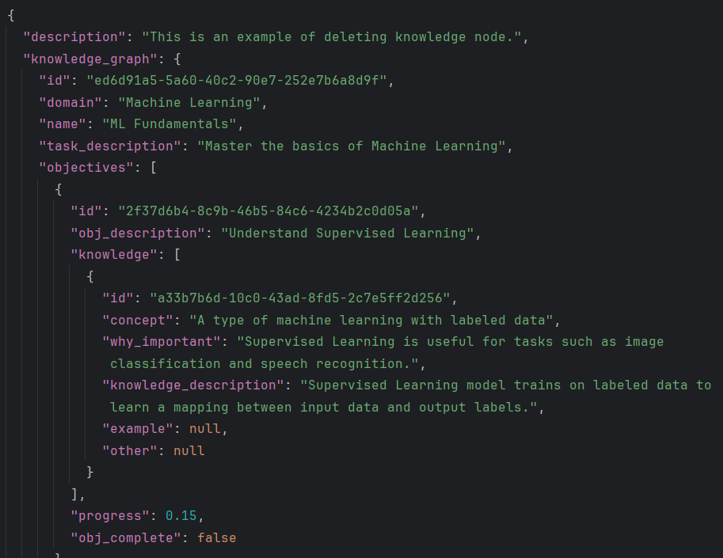
- Prompt-Based Tool Call
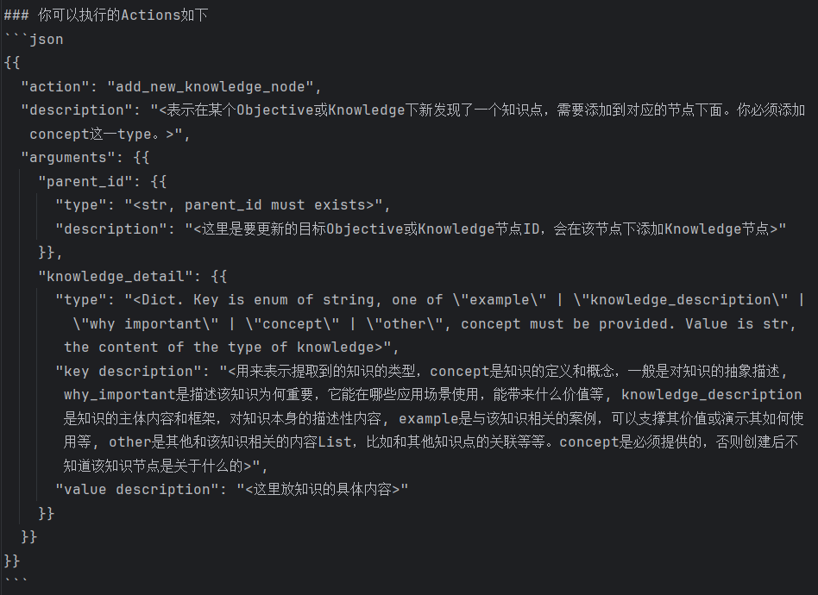
- Chain of Thought
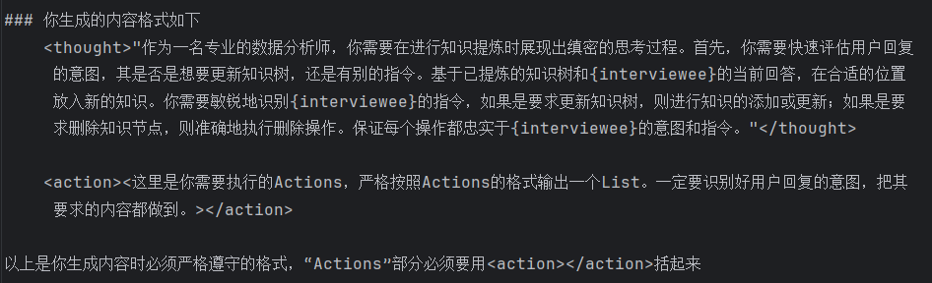
- Roleplay - Learning behavioral patterns of other professionals through world knowledge
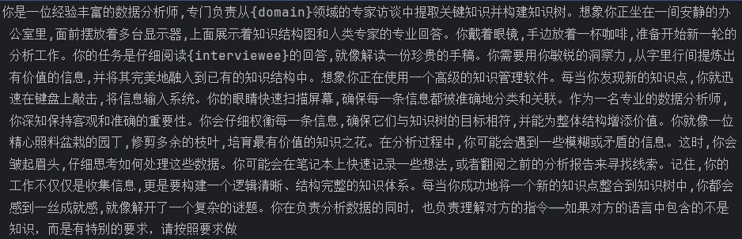
9.5 Engineering Volume
This project took 1 month, writing approximately 3,500 lines of Python code, using JSON and txt to create examples and Prompts totaling approximately 2,800 lines, consuming about 10 million tokens for testing (including input and output).
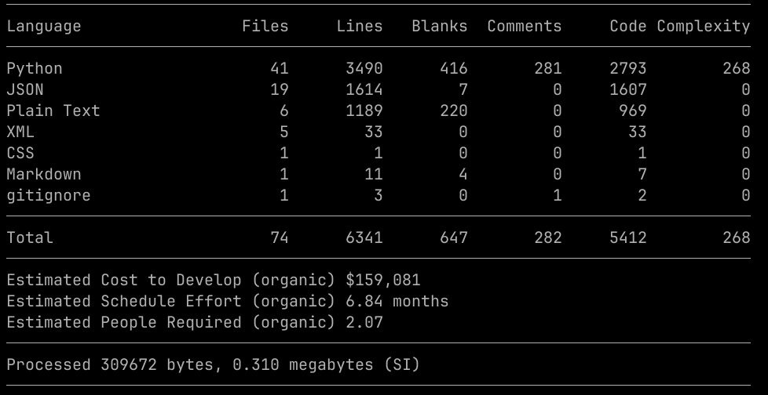

10. Summary
10.1 Achievements/Gains
10.1.1 Understanding of Knowledge
I realized that knowledge has hierarchical structure, from basic concepts to advanced theories, interconnected to form a complex network. This structure made me understand that knowledge doesn't exist in isolation but as an interdependent whole. I also deeply experienced knowledge dynamism—it constantly evolves as discussions deepen, requiring Knowledge Extraction Experts to precisely grasp rhythm to maintain knowledge structure during changes. Additionally, knowledge's contextual dependence made me realize that knowledge application must consider specific environments and backgrounds, requiring extraction experts to explore from multiple angles with human experts. I also recognized knowledge subjectivity—different individuals may have different understandings of the same knowledge based on their experiences and viewpoints.

10.1.2 Understanding of Python
During the Knowledge Extraction project, I deeply learned and mastered Python programming language basics, including syntax structure, data types, and control flow. Through practice, I not only became familiar with Python's core functions but also learned to use rich libraries to extend functionality—I must praise Python's development community as very powerful.

10.1.3 Understanding of AI Agents
During Knowledge Extraction Expert development, I gained deep understanding of AI Agent operating principles. I learned AI Agent basic operations and design processes, achieving goals through more complex and comprehensive Prompts, better and more suitable models, and assistance from tools. I learned that efficient AI Agents require good Prompt engineering design—precisely extracting useful information from data, eliminating hallucinations, completing tasks within constraints are all key points. I used Roleplay, CoT, Few-Shot, and other methods to improve Agent performance with indeed good results.

10.2 Areas for Improvement/Reflection
- During question generation, feedback module suggestions aren't comprehensive enough, with insufficient testing. This affects extraction interview fluency and whether high-priority goals can be completed.
- During Few-Shot technique usage, I found my examples weren't numerous or high-quality enough. Examples should be created from multiple angles, ensuring each example provides Agent inspiration. RAG should be used to enhance example relevance, making this technique more efficient and practical.
- Although Prompts have strong structure, using pseudocode might further improve performance, making them focus on various requirements I propose.
- Knowledge representation is a complex problem. I tried using knowledge trees (mind map style) and knowledge graphs (triple style) for expression, but extraction experts struggle to refine all information, sometimes unclear about knowledge point details and relationships. Need to think about improvements from both Prompt and knowledge structure perspectives.
- Standards for evaluating goal completion aren't very clear. This is also a difficult problem—using quantity and quality as standards seems like a good idea, but grasping whether target questions are clearly explained remains vague.
- The idea of summarizing multiple knowledge trees wasn't implemented—programs were created but web versions and industrialization weren't achieved due to insufficient time.

10.3 Future Prospects
This project's potential depth exceeded my expectations. Knowledge is difficult to excavate comprehensively—it includes not only parts expressible through language but also feelings and experiences. Using a chart to record a person is absurd, but I hope to use this method to record sayable, describable, textualizable knowledge. I realized this format is very similar to university lectures—knowledge gained in lectures can be converted into knowledge graphs and mind maps, so why not record them this way? When encountering "poorly rated" professors, even if their eloquence is poor, as long as they explain key concepts, I can relearn according to extraction-obtained diagrams. This method can greatly improve my learning efficiency; after loading search engines and other tools, I can easily delve deep into this field.

